HUE TEST

Which kind of light is most noticeable?

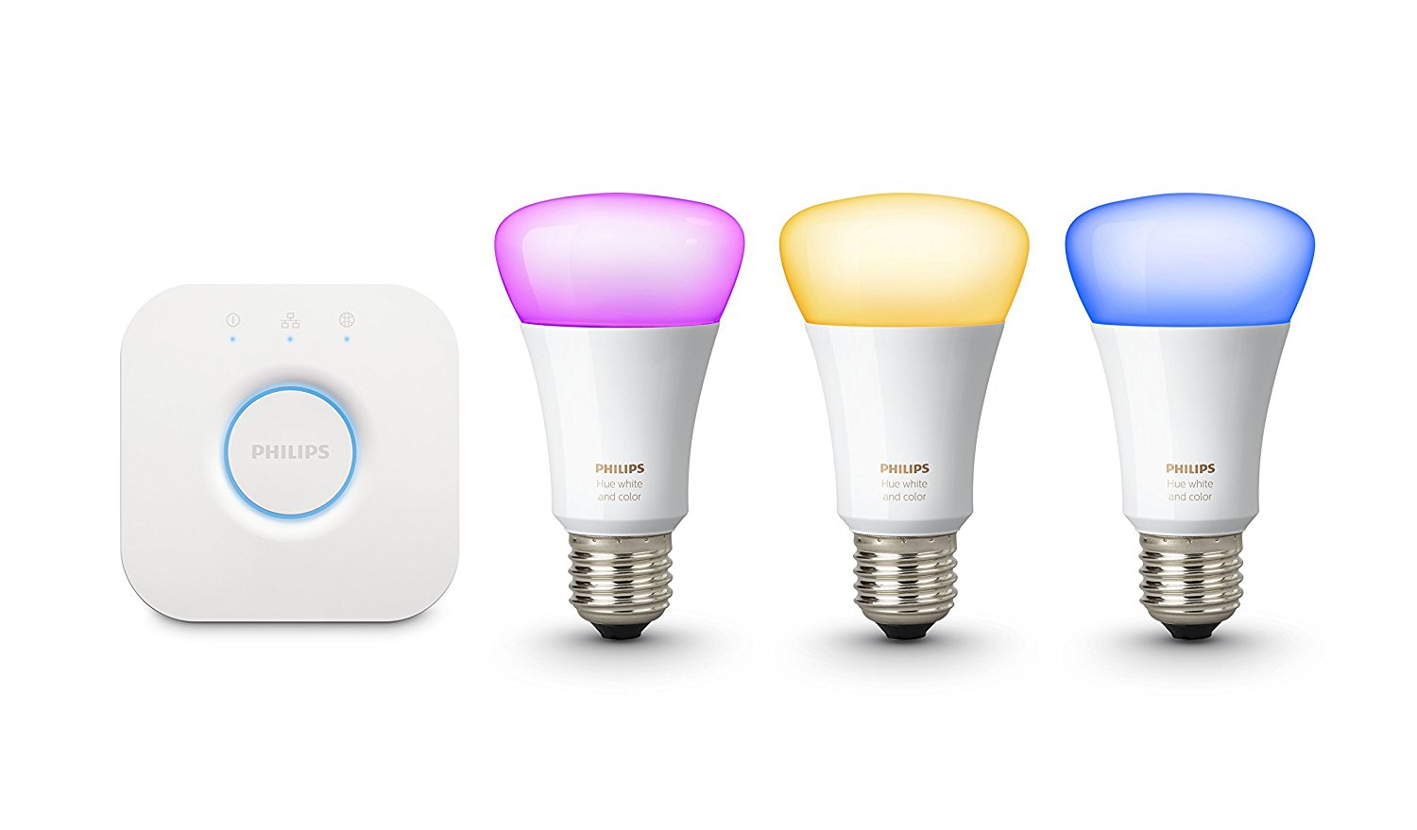

**Anders & Bart**

25-5-2018

GROUP 1 - PROFTAAK OCÉ

# 

# INTRODUCTION

After the feedback from the client and the lecturers, we planned this test to make our concept stronger. The unique selling point of our concept, the fading light, falls and stands on the fact that is noticed by the worker in the factory. We want to know, which kind of light is the most noticeable; critical errors should have an alert that is noticeable.

Therefore, we want to test if people notice a light changing color. We have also included a flashing light, to test if that is easier to notice.

Before we started the test, we have done some research about the human field of view. Based on the outcome of this research, we composed our hypothesis.

# RESEARCH

Field of view: “The approximate field of view of an individual human eye is 95° away from the nose, 75° downward, 60° toward the nose, and 60° upward, allowing humans to have an almost 180-degree forward-facing horizontal field of view.”[1]

RESEARCH QUESTIONS

Does the test person notice the different light settings?

Which kind of light is most noticeable in a wide angle?

# HYPOTHESIS

If the light is placed out of the field of view, the light will not be noticed by the test person.

# 

# EQUIPMENT

1. Philips Hue bulb, Bridge and Router.
2. Computer with simple questions and 2 minute timer.
3. Camera to film the test.

# PROCEDURE

1. Test person enters the room, sits down at the table. The tester explains the test and starts the timer. The light is still off at this point. Test person does not know about the light. Test person thinks, he/she should answer some questions for two minutes.
2. The test person answers the questions, and tester 1 turns on the light. Tester 2 checks if the test person notices the light turning on.
3. Tester 1 blinks the light and tester 2 again, checks if the test person notices.
4. Tester 1 Fades the light from green to red. Tester 2 checks if the test person notices any change.

# DATA

|  |  |  |  |  |
| --- | --- | --- | --- | --- |
| TEST PERSON | BULB POSITION | NOTICED WHITE LIGHT | NOTICED FLASHING | NOTICED FADING |
| PERSON 1 | Far right |  |  |  |
| PERSON 2 | Far right |  |  |  |
| PERSON 3 | Closer right |  |  |  |
| PERSON 4 | Almost in front of the computer |  |  |  |

# 

# RESULTS

The first test person didn’t noticed the light at all. We wanted to try with another person with the light in the same spot. The second test person noticed the lights flashing, but didn’t notice the white or fading light. Therefore, we decided to move the light a little bit closer to the computer, which means the light would be a little bit closer to the central horizontal field of view.

The third test person noticed every kind of light. We moved the light even closer to the computer, and the fourth test person noticed every kind of light but the fading. The last test person was used as a ‘benchmark’ - we we’re sure that at least some of the lights were being noticed.

# CONCLUSION

The outcome of the test is backed by the research we did beforehand. The further away the light is placed, the less the light gets noticed. The flashing light is more noticeable at a wide angle than a change of color.

# RECOMMENDATION

Our concept can be improved with the outcome of the test. When a critical situation needs quick response, the light indicating the situation starts flashing. This way the chance of noticing is increased.

# SOURCES

1. Source: <http://www.cdcc.usp.br/cda/cursos/2015/licenciatura-2015-08-21-telescopios/Human%20eye.pdf>
2. Video: <https://youtu.be/5H67S4Pyuq4>

1. Check the links section for source.